Platform Architecture
A reusable platform for Niro's health calculators
Prepared 18 August 2026 Version 1.0
1. Purpose of this document
This document describes how the Niro Health Calculator Platform is put together. It explains the main building blocks, how they work with each other, and why the design makes it easy for the team to add new calculators in the future without new development work. The architecture diagram on the next page is intended to be readable by anyone, regardless of technical background.
2. What we are building
Niro is creating a public website that offers a growing collection of health calculators. A visitor answers a short set of questions, adds lab values if they have them, and receives a clear score together with an explanation and sensible next steps. The site also includes a health library with plain-language pages about each health marker, similar in spirit to the existing NirogGyan biomarkers page.
The most important requirement behind the design is flexibility. The team should be able to create a new calculator, or adjust an existing one, in roughly the way one publishes a blog post: fill in the questions, set the scoring rules, review, and publish. To make that possible, the platform is built as one core system that reads “calculator definitions”. Each calculator is a set of stored instructions, not a separate piece of software.
At a glance | Summary
Purpose | A public, search-friendly hub of health calculators that also supports Niro's wider product goals
First calculators | Comprehensive Wellness Score, Heart Risk, Diabetes Risk, and Hypothyroid Risk, all defined in Niro's risk-logic documents
Who uses it | Visitors taking assessments, and the Niro team managing calculators through an admin area
Technology | MongoDB, Express.js, React and Node.js (the MERN stack)
Key principle | New calculators are added as data through the Calculator Studio, so the core system never needs to be rebuilt

3. The architecture
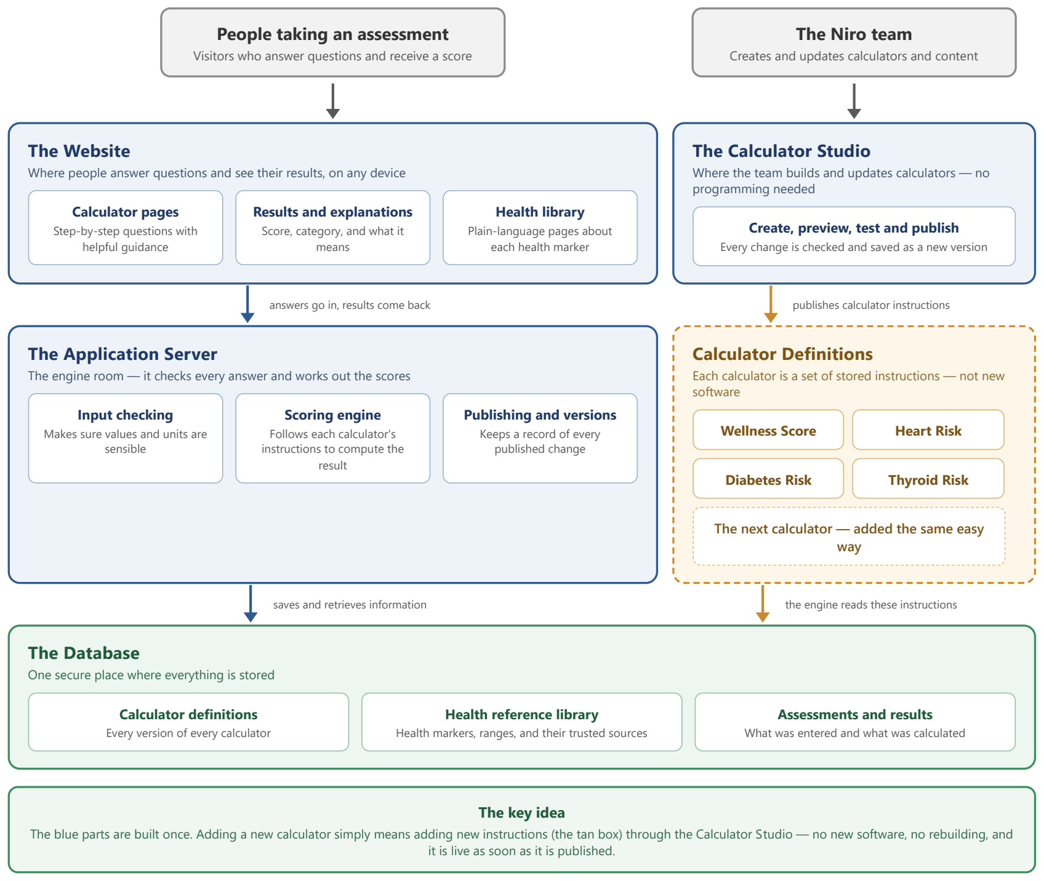
The diagram below shows the whole platform. Blue parts are the core system, built once. The tan box holds the calculator definitions, which is the only thing that changes when a calculator is added or updated. Green is where information is stored.

4. The main components
Component | What it does
The Website | The pages visitors see. It presents each calculator's questions step by step, converts units where needed, and displays the results with explanations. The same pages work for every calculator because they are generated from the calculator's definition.
The Calculator Studio | A private admin area where the team creates and edits calculators: the questions, the scoring rules, and the result messages. It includes preview, automatic checks, and test runs, so nothing incorrect can be published by accident.
The Application Server | The engine room. It checks every submitted answer, runs the scoring engine, and keeps a record of each published version of each calculator.
Calculator Definitions | The stored instructions for each calculator: which questions to ask, how to score each answer, how to weight the results, and what to say to the user. The Wellness Score, Heart Risk, Diabetes Risk and Hypothyroid Risk calculators all live here.
The Database | One secure store for the calculator definitions, the health reference library with its sources, and the assessments and results.
5. What happens when someone takes an assessment
1. Open calculator → Show questions and guidance.
2. Enter answers → Support units and skipped values.
3. Validate answers → Check completeness and validity.
4. Calculate score → Determine score, category, and factors.
5. Save result → Store assessment with calculator version.
6. Show results → Display score, reasons, details, and recommendations.
6. How a new calculator is added
- Create calculator → Add name and description.
- Add questions → Use health library with pre-filled units and guidance.
- Set scoring → Configure ranges, age/sex rules, and categories.
- Preview & test → Verify questions and expected scores.
- Publish → Make it live and keep version history for rollback.
No developer is involved in these steps, and nothing in the core system changes. This was proven during design by expressing four quite different Niro calculators, from a simple additive checklist to a modified Framingham heart-risk model, in the same definition format.

